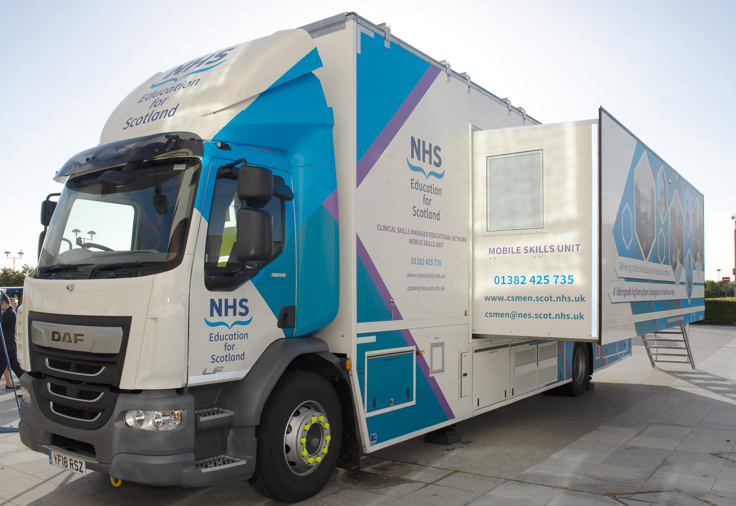
Mobile Skills Unit Training Programme: [insert date]

The MSU will be parked at: [insert venue]

Please contact [insert contact details] for more information or if you would like to attend one of the sessions.

Mobile Skills Unit Training Plan: Week 1 commencing [insert date]

 | Monday | Tuesday | Wednesday | Thursday | Friday
Morning session

Morning session | Faculty: | Faculty: | Faculty: | Faculty: | Faculty:
Afternoon session

Afternoon session | Faculty: | Faculty: | Faculty: | Faculty: | Faculty:

Mobile Skills Unit Training Plan: Week 2 commencing [insert date]

 | Monday | Tuesday | Wednesday | Thursday | Friday
Morning session

Morning session | Faculty: | Faculty: | Faculty: | Faculty: | Faculty:
Afternoon session

Afternoon session | Faculty: | Faculty: | Faculty: | Faculty: | Faculty:

